Window Builder in Java/Eclipse

First go to site: <http://eclipse.org/windowbuilder/download.php>

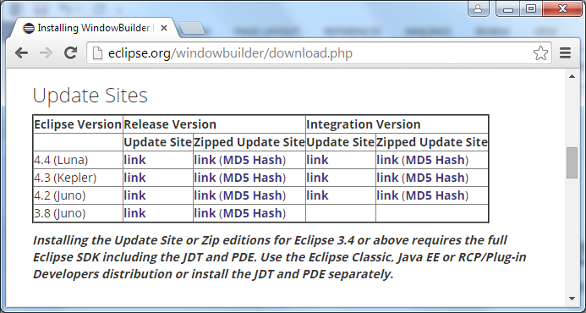

Press Link on 3.8 (Juno) and copy resulting link

i.e. <http://download.eclipse.org/windowbuilder/WB/release/R201406251200/4.2/>

Now Open Eclipse => Help => Install New S/W

Enter Link and press Add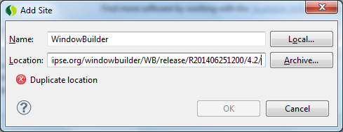

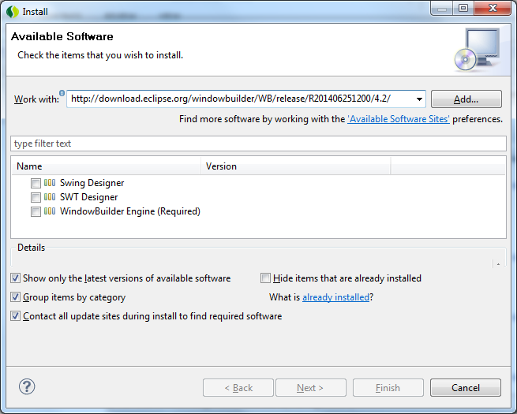

Now Select Swing Builder Designer

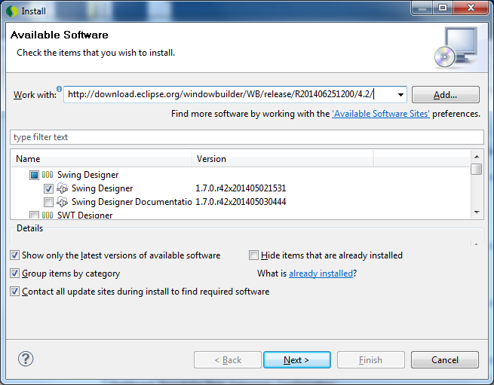

Next, Finish etc to load Software.

Now to Create a Windows App, using Window Builder

1. Create a New Java Project, lets call it testGUI1
2. Create a Windows Application

File>new>Other>WindowBuilder>ApplicationWindow

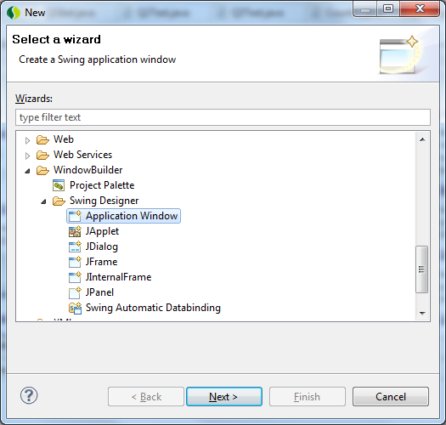

Next, give it the name ‘start’ and make sure its associated with the ‘testGUI1’ project

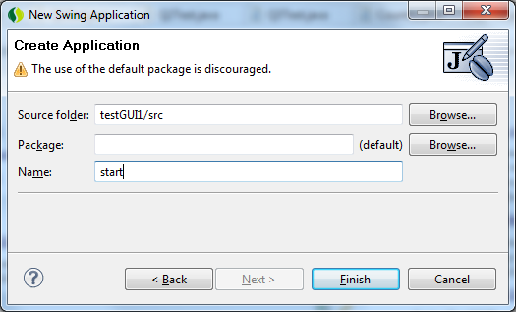

Finish: Click on Design

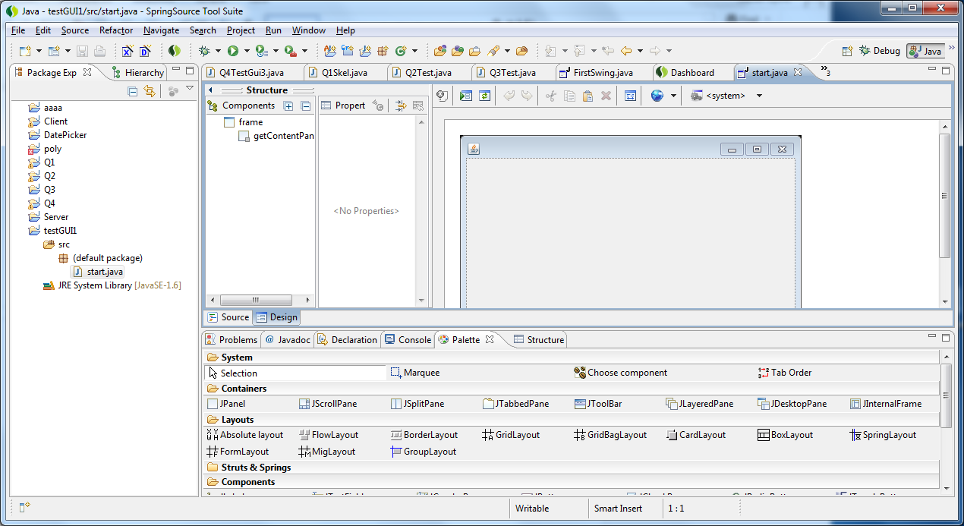

Click on this icon

Now You have the Best Design Layout Layout

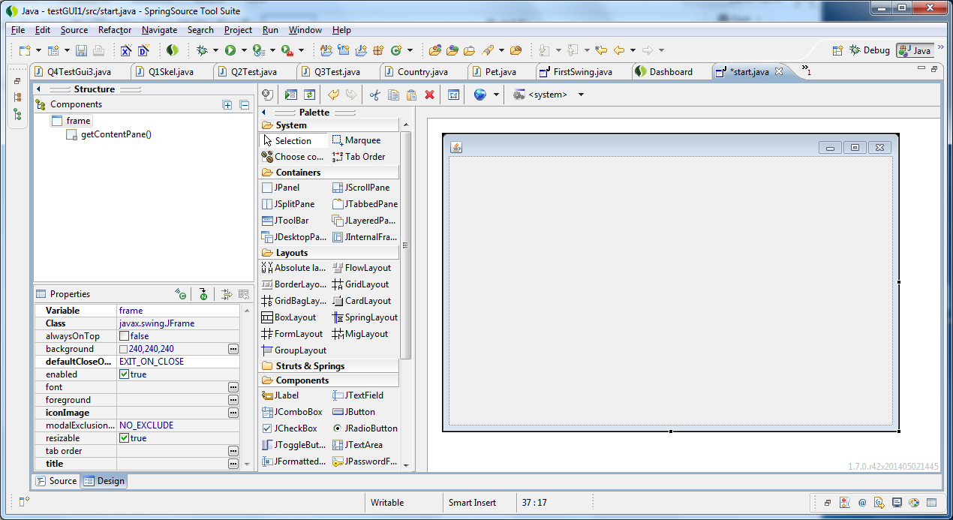

Right Click Here & change Layout to Absolute Layout

Drag in First Label & Use Property Window to Change details as follows

Variable: label1

Text: Value1

Font: 16

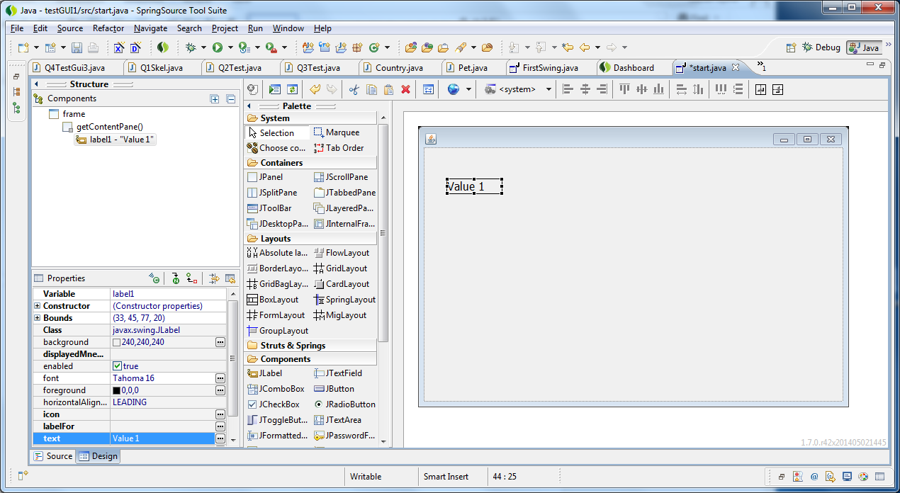

Now we complete the application as follows:

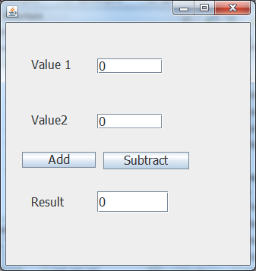

textField1

textField2

textField3

Now we want to do event handling by clicking on Add button

**btnAdd.addActionListener(new ActionListener() {**

**public void actionPerformed(ActionEvent e) {**

**int val1=Integer.*parseInt*(textField1.getText());**

**int val2=Integer.*parseInt*(textField2.getText());**

**int res = val1 + val2;**

**textField3.setText("" + res);**

**}**

**});**

No want to add a CheckBox afterwards: (slight flaw in tool here)

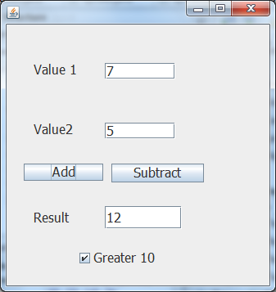

checkBox1

But there is a problem to resolve: JCheckBox checkBox1; added in wrong place;

Need to modify code as follows:

~~JCheckBox~~ checkBox1 = new JCheckBox(“Greater 10”); // at bottom

**public** **class** start {

**private** JFrame frame;

**private** JTextField textField1;

**private** JTextField textField2;

**private** JTextField textField3;

JCheckBox checkBox1; // inserted at top

Overall Code looks like this:

**public** **class** start {

**private** JFrame frame;

**private** JTextField textField1;

**private** JTextField textField2;

**private** JTextField textField3;

JCheckBox checkBox1;

:

JButton btnAdd = **new** JButton("Add");

btnAdd.addActionListener(**new** ActionListener() {

**public** **void** actionPerformed(ActionEvent e) {

**int** val1=Integer.*parseInt*(textField1.getText());

**int** val2=Integer.*parseInt*(textField2.getText());

**int** res = val1 + val2;

textField3.setText("" + res);

**if** (res > 10)checkBox1.setSelected(**true**);

**else** checkBox1.setSelected(**false**);

}

});

:

//JCheckBox checkBox1 = new JCheckBox("Greater 10");

checkBox1 = **new** JCheckBox("Greater 10");

checkBox1.setFont(**new** Font("Tahoma", Font.*PLAIN*, 16));

checkBox1.setBounds(85, 271, 145, 28);

frame.getContentPane().add(checkBox1);

}

}